PLATE TECTONICS, VOLCANOES, EARTHQUAKES, FOSSILS, and EARTH’S AGE
- Which layers of the Earth make up the Lithosphere or tectonic plates?
- Core
- Crust
- Upper mantle
- Asthenosphere

- The Asthenosphere is contained in which layer of the Earth?
- Crust
- Outer core
- Inner core
- Mantle

- What type of heat transfer causes the movement of tectonic plates?
a. conduction
b. convection
c. radiation
d. electromagnetic waves

- How do plates move over time?
a. volcanoes and earthquakes causes plates to move
b. convection currents in the aesthnosphere cause lithospheric plates to move
c. convection currents in the Earth’s core cause plates in the mantle to move
d. radiation from the center of the Earth heats the plates

- When volcanoes form in the middle of a plate, instead of at a plate boundary, scientists can predict that those volcanoes are over:
a. subduction zones
b. massive holes in the mantle
c. hot spots
d. cold spots

Match the following plate boundary types to the images below:
A. Transform B. Convergent – subduction C. Convergent – continental collision D. Divergent

6. ____________ 7. ____________ 8. ____________ 9. ____________

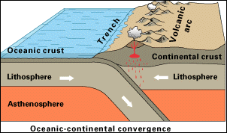(continent-continent) (ocean-ocean) (continent-continent) (ocean-continent)

Use the image below to answer questions 10-13

- What type of boundary is located at J?
a. divergent
b. convergent
c. transform
d. subduction

- What landform is most likely to form at G?
a. mountains
b. a volcano
c. weathered rock formations
d. mid-ocean ridge or sea-floor spreading

- What landform is most likely to form at E?
a. mountains
b. a volcano
c. weathered rock formations
d. mid-ocean ridge or sea-floor spreading

- What landform is most likely to form at I?
a. mountains
b. a volcano
c. weathered rock formations
d. mid-ocean ridge or sea-floor spreading

- Volcanoes and earthquakes most often occur where?
a. in the middle of tectonic plates
b. on the edges of tectonic plates
c. volcanoes and earthquakes do not relate to tectonic plates

- Identify the two types of volcanoes:
a. shield, congruent
b. Basalt, cinder cone,
c. shield, composite
d. spherical, composite

- Which type of volcano is more likely to build a steep, high slope mountain of rock and ash?
a. composite
b. shield
c. basalt
d. hot spot

- Which type of volcano is more likely to build a low, flat mountain?
a. cinder cone
b. shield
c. tephra
d. hot spot

Match each of the images below to the three types of faults:
- Normal B. Reverse C. Strike-slip
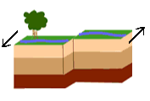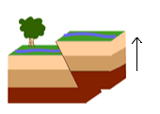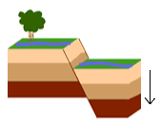

- ________________ 22. _________________ 23. _________________

24. What is absolute dating?
a. Dating that gives an exact date using fossils
b. Dating that gives an exact date using radioactive atoms
c. Dating that gives an estimated date using fossils
d. Dating that gives an estimated date using radioactive atoms

25. What is relative dating?
a. Dating that gives an exact date using fossils
b. Dating that gives an exact date using radioactive atoms
c. Dating that gives an estimated date using fossils
d. Dating that gives an estimated date using radioactive atoms

26. What is the longest and oldest era of geologic time?
a. Precambrian b. Paleozoic c. Mesozoic D. Cenozoic

27. What does the law of super positioning say about horizontal layers of sedimentary rocks?
a. The oldest layer is on the bottom layers above are younger
b. The oldest layer is on the top, and layers below are younger
c. The youngest layer is on the bottom, and layers above are older
d. There is no pattern of age in layers of sedimentary rock

28. What is an index fossil?
a. A fossil of an organism that existed for a short time and gives scientists an estimation of how old something is
b. A fossil of an organism that existed for a short time that gives scientists an exact date of how old something nearby is
c. A fossil of an organism that existed for a long time and gives scientists an estimation of how old something is
d. A fossil of an organism that existed for a long time that gives scientists an exact date of how old something nearby is

29. A rare dinosaur fossil is found in the same rock layer as a Mucrospirifer, an index fossil that existed between 416 and 359 million years ago. How old is the dinosaur fossil?
a. before 416 million years ago
b. between 416 and 359 million years ago
c. after 359 million years ago
d. between 400 and 375 million years ago

Match each of the following to the type of fossil it is:
- Trace | 30. ________ | 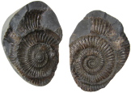 | An imprint of a seashell
- Mineralization | 31. ________ | 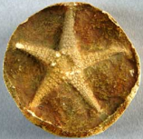 | A mineral representation of a starfish
- Preservation | 32. ________ |  | Footprints in a rock
- Mold | 33. ________ | 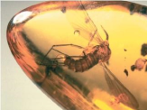 | Insect preserved in amber
- Cast | 34. ________ | 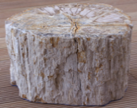 | Minerals have fossilized or petrified wood
35. What is radioactive dating?
a. Use of fossils to get an absolute date of rocks
b. Use of isotopes and half-lives to get a relative date of rocks
c. Use of fossils to get a relative date of rocks
d. Use of isotopes and half-lives to get an absolute date of rocks

36. Radioactive dating is calculated by:
a. the half life of an element, which is the rate at which parent elements change to daughter elements
b. the radiation from the sun changing the dates of rocks
c. radioactive nuclear waste changing the dates of rocks
d. the half life of an element, which scientists cannot calculate

37. Which of the following events came first?
a. Mammals appeared
b. Birds appeared
c. Fish appeared
d. Reptiles appeared

38. What is evolution?
a. The sudden adaptation of an organism to its environment
b. A gradual change in a species over time
c. How the earth changes over time

Match the type of rock with how it is formed:

39. Igneous A. Form when rocks undergo a lot of change often with heat and pressure
40. Metamorphic B. Form when pieces of different types of rock get compacted together
41. Sedimemtary C. Form from the cooling and hardening of magma
Complete on your ANSWER SHEET!
- Explain how weathering occurred in the image below. Is it chemical or mechanical weathering?
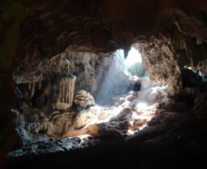 | What is it? | What process is happening and how? | Is it chemical or mechanical?
 | A limestone cave
- Explain how weathering occurred in the image below. Is it chemical or mechanical weathering?
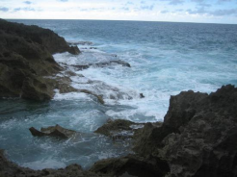 | What is it? | What process is happening and how? | Is it chemical or mechanical?
 | Waves crashing against rocks on a beach
Choose FOUR of the following questions to answer on the back of your answer sheet. Each question will be worth three points each. If you answer more than two, you can earn extra credit!!!
- Why was the development of cyanobacteria so important in the history of the Earth?
- What is the difference between an index fossil and a trace fossil? Why are index fossils important to paleontologists?
- How do we know that tectonic plates have moved through the history of the Earth?
- What is the difference between a period, an epoch, and an era?
- What is the Pacific Ring of Fire and why is it so significant?
- What is the difference between weathering and erosion?
- What is natural selection and why is it important?
- What are the seven areas of classification and how do they help us determine how organisms are related?
PLATE TECTONICS, VOLCANOES, EARTHQUAKES, FOSSILS, and EARTH’S AGE
1.
2.
3.
4.
5.

Matching
6. | 7. | 8. | 9.

10.
11.
12.
13.
14.
15.
16.
17.
18.
19.
20.
21.

Matching
22. | 23. | 24.

25.
26.
27.
28.
29.

Matching:
30.
31.
32.
33.
34.

35.
36.
37.
38.
39.
40.
41.
Short Answer:
- Explain how weathering occurred in the image below. Is it chemical or mechanical weathering?
 | What is it? | What process is happening and how? | Is it chemical or mechanical?
 | A limestone cave

- Explain how weathering occurred in the image below. Is it chemical or mechanical weathering?
 | What is it? | What process is happening and how? | Is it chemical or mechanical?
 | Waves crashing against rocks on a beach

SHORT ANSWER: PLEASE WRITE THE NUMBER OF THE QUESTION YOU ANSWERED
____________________________________________________________________________________________________________________________________________________________________________________________________________________________________________________________________________________________________________________________________________________

____________________________________________________________________________________________________________________________________________________________________________________________________________________________________________________________________________________________________________________________________________________

BONUS:
In Missouri, we can find fossils of seashells and ocean creatures. What does this tell us about Missouri’s history?
__________________________________________________________________________________________________________________________________________________________________________

